**Procedure for the Calibration of Micropipettes using the Gravimetric Method**

**PRINCIPLE:**

Micropipettes are precision laboratory instruments. They require routine maintenance and calibration to ensure accuracy and precision. The gravimetric methodology of pipette calibration is performed by using an analytical balance and weighing the amount of water delivered by the pipette. Calculation of the standard deviation and the coefficient of variation are used to determine the accuracy and precision of each pipette.

**AUTHORITY & RESPONSIBILITY:**

1. The Director (or designee) of the Laboratory has the authority to establish this procedure.
2. The Principal Investigator/Laboratory Manager is responsible for the implementation of this procedure and for ensuring that all appropriate personnel are trained.
3. All technologists and technicians working on clinical trial studies are responsible for reading and understanding this SOP prior to performing the procedures described.

**EQUIPMENT:**

1. Micropipettes for calibration
2. Analytical balance
3. Calculator with statistical program, computer with statistical software, or standard calculator.

**PRECAUTIONS:**

Standard precautions, outlined in the laboratory’s safety manual, will be followed during the performance of this procedure.

**MATERIALS/DISPOSABLES:**

1. Appropriate personal protective equipment
2. Plastic pipette tips
3. Plastic weigh boats
4. Worksheet for Micropipette Calibration

**REAGENTS:**

Reagent grade water at room temperature

**CALIBRATION:**

Per DAIDS Guidelines for GCLP:

“DAIDS requires that pipettors be checked for accuracy and reproducibility and recalibrated at least once every six months.

Pipettor malfunction is one of the most common sources of laboratory error. DAIDS strongly recommends that laboratories perform checks for accuracy, reproducibility, and recalibrations four times per year.”

The complete calibration consists of testing both accuracy and precision of all micropipettes outlined in this procedure.

For variable volume pipettes, three volume setting should be tested:

1. Nominal volume (the largest volume specified by the manufacturer)
2. 50% of nominal volume
3. 10% of nominal volume

For fixed-volume pipettes, only the nominal volume is tested.

For multichannel pipettes, each channel must be checked separately.

*Guidelines for Acceptable Calibration Results:*

Precision and accuracy acceptability is based on the guidelines suggested by the manufacturer in the pipette package insert.

**PROCEDURE**:

1. Allow the pipette, water, and the balance to equilibrate to the room’s temperature, humidity, and barometric pressure.
2. Record ambient room temperature, humidity, and barometric pressure.
3. Select the test volume if using a variable-volume pipette.
4. Fit the manufacturer-recommended tip onto the pipette.
5. Place a plastic weigh boat on the balance and tare the balance.
6. Pre-wet the tip five times by slowly and evenly aspirating and expelling the water from the tip.
7. Pipette room temperature reagent grade water into the tip using good pipetting technique.
8. Carefully remove any droplets adhering to the outside surface of the pipette tip.
9. Dispense the test volume into the weigh container, taking care to accurately deliver the test volume.
10. Record the mass after the weight has stabilized.
11. Repeat the above steps 10-20 times (depending on the criteria for accuracy and precision established by your laboratory).
12. Calculate the mean, and convert the mean measured mass value into volume using the Z-factor tables for deionized water provided by the pipette manufacturer.

NOTE: The Z-factor corrects for the effects of temperature and barometric pressure on the density of water. See example Z-factor table at the end of this procedure.

1. Record the values on a worksheet and perform calculations below. (See related document Pipette Calibration Worksheet).

**CALCULATIONS:**

Accuracy

Calculate the mean of the readings obtained. Compare to the manufacturer's specifications for accuracy.

Precision:

Using a statistical calculator or statistics software program such as Microsoft Excel, calculate the Standard deviation (SD) and coefficient of the variation (CV) for the number of pipette readings obtained. Compare to the manufacturer's specifications for precision.

**REPORTING RESULTS:**

The reading obtained and calculations are recorded on the worksheet for micropipette calibration and stored in a designated file or binder.

Record the actual accuracy of the pipette, the date of the calibration and the initials of the person completing the calibration on a label and attach to the pipette.

**RELATED DOCUMENTS**:

Worksheet for Pipette Calibration (available on pSMILE.org Resources)

Z-Factor Table below (example only. Use the table that is provided by your pipette manufacturer).

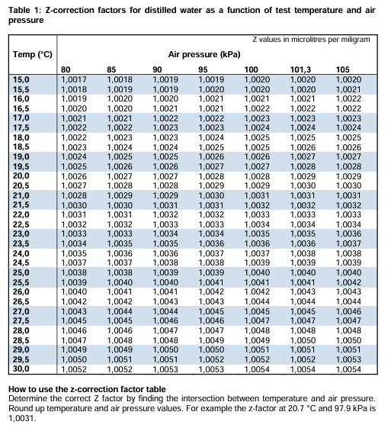

**REFERENCES:**

1. Clinical and Laboratory Standards Institute (CLSI) General Laboratory Equipment Performance Qualification, Use, and Maintenance. CLSI QMS23 2nd Edition, June 2019. CLSI 950 West Valley Road, Suite 2500, Wayne, PA 19087
2. Good Clinical Laboratory Practice Guidelines, NIH Bethesda, MD 20892. 2021 v.4.1
3. Operating Instructions for Eppendorf Pipette. (ND). Brinkman Instruments Inc. N.Y. 2019
4. International Organization for Standardization. (2022). Piston-operated volumetric apparatus — Part 5: Dispensers (ISO Standard No. 8655-5: 2022). <https://www.iso.org/standard/68800.html>